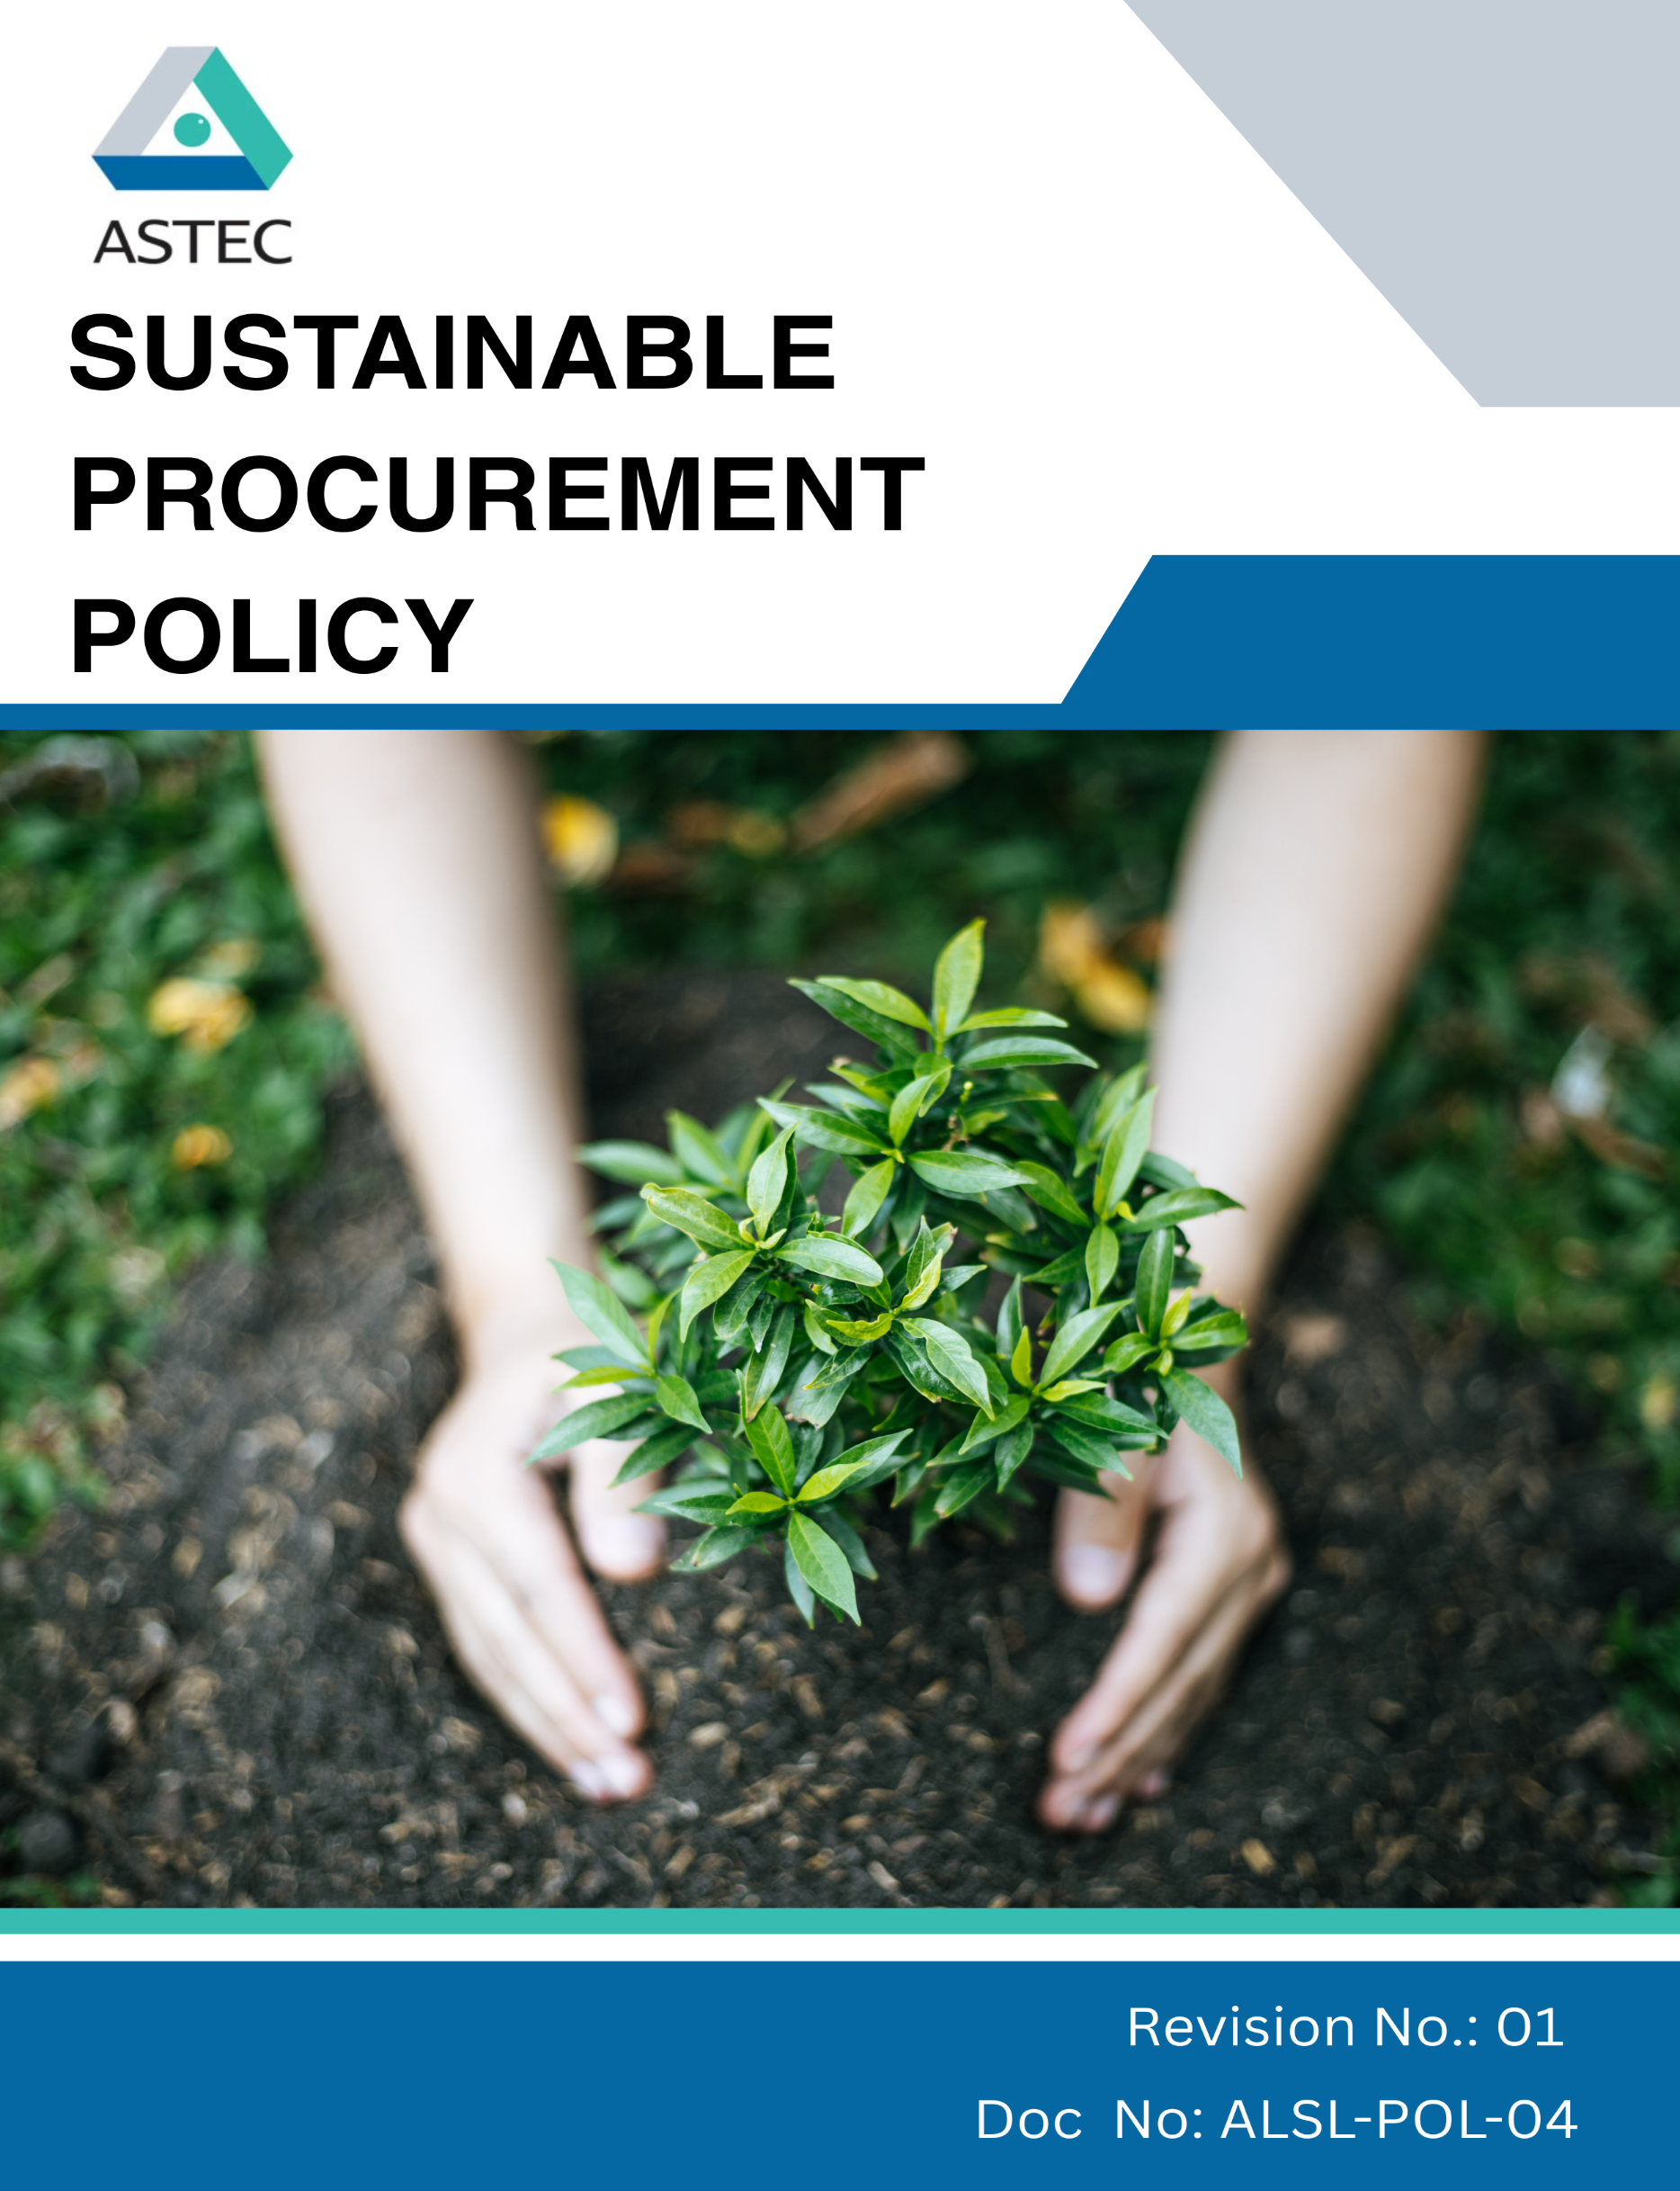
Contents

Preface 3
Policy Declaration 3
Scope 3
Key Focus Areas 4
Qualitative Objectives 5
Quantitative Targets 6
Alignment with the United Nations Sustainable Development Goals (SDGs) 7
Responsibilities 7
Review Mechanism 7
Employee Acknowledgment Form 9

Preface
Astec LifeSciences Ltd. is committed to responsible and sustainable sourcing practices that align with our environmental, social, and ethical values. Our Sustainable Procurement Policy guides the selection, evaluation, and engagement of suppliers and partners to ensure that goods and services are sourced in a manner that promotes environmental stewardship, ethical labor practices, compliance with laws, and positive social impact. This policy reflects our dedication to minimizing environmental footprint, supporting fair labor standards, fostering innovation, and building long-term, transparent, and responsible relationships with suppliers. By integrating sustainability into procurement decisions, we aim to contribute to the company’s overall ESG objectives and the broader Sustainable Development Goals (SDGs).

Policy Declaration
Astec LifeSciences Ltd. is committed to responsible, ethical, and sustainable procurement. All employees, suppliers, and partners are expected to comply with laws, environmental standards, and human rights principles, integrating sustainability into procurement decisions. The company enforces this policy through training, monitoring, and reporting, and non-compliance may lead to corrective or disciplinary action.

Scope
This policy applies to all employees, officers, and representatives of Astec LifeSciences Ltd., as well as suppliers, contractors, and vendors. It covers all procurement activities across following sites, including sourcing of materials, equipment, and services, ensuring compliance with ethical, social, and environmental standards.:

Site | Address
Astec LifeSciences  Limited | - Plot Nos. B-16, B-17, B-18 & B-21, MIDC Mahad, Birwadi Industrial Area, Taluka Mahad, District Raigad – 402 302, Maharashtra  - Plot No. K-2/1/1, Additional MIDC Mahad, Village Kalinj, Taluka Mahad, District Raigad – 402 302, Maharashtra  - Plot No. K-2/1/2, Additional MIDC Mahad, Village Kalinj, Taluka Mahad, District Raigad – 402 302, Maharashtra  - Plot No. K-2/2, K-2/3/1, Additional MIDC Mahad, Village Kalinj, Taluka Mahad, District Raigad – 402 302, Maharashtra
Research & Development Centre | Plot No. B-23, T.T.C., Pipeline Road, T.T.C. Industrial Area, Airoli, Navi Mumbai – 400 708, Maharashtra
Astec LifeSciences Limited (Corporate Office) | Godrej One, 3rd Floor, Pirojshanagar, Eastern Express Highway, Vikhroli (East), Mumbai – 400079, Maharashtra

Key Focus Areas
- Environmentally Responsible sourcing: Engage with suppliers who actively minimize environmental impacts through resource efficiency, emission control, and responsible waste management.
- Supplier Social Responsibility Framework: Commitment to safe workplaces, fair wages, and the elimination of child, forced, or exploitative labor across tier-1 supplier.
- Ethical Supplier Conduct: Expectation of legal compliance, anti-corruption, and full transparency in business practices from all partners.
- Local & Inclusive Sourcing: Support for community-based suppliers and inclusion of diverse, small, and responsible enterprises in the supply base.

Qualitative Objectives
- Environmentally Responsible sourcing
- Promote environmentally sustainable procurement by partnering with suppliers who demonstrate measurable environmental responsibility.
- Encourage continuous improvement in supplier environmental performance through training and collaboration.
- Emphasize sourcing from suppliers with recognized environmental compliance certifications.

- Supplier Social Responsibility Framework
- Promote awareness and compliance with anti-child labor and anti-forced labor practices across the supply chain.
- Guarantee that all suppliers adhere to fair labor practices, including the prohibition of child and forced labor, provision of fair wages, and assurance of safe working environments.
- Support supplier initiatives that improve workforce welfare and social accountability.

- Ethical Supplier Conduct
- Ensure suppliers comply with all applicable laws, regulations, and anti-corruption standards.
- Encourage transparency and accountability in supplier business operations.
- Promote a culture of ethical behavior and responsible decision-making among all supply chain partners.

- Local & Inclusive Sourcing
- Increase engagement with community-based and small-scale suppliers.
- Support diversity and inclusion by integrating underrepresented suppliers into the supply base.
- Foster long-term partnerships with suppliers who demonstrate social and environmental responsibility.

Quantitative Targets
To translate our commitment into measurable progress, Astec LifeSciences Ltd has defined specific objectives and targets aligned with our key focus areas. These goals are designed to promote ethical sourcing, strengthen supplier accountability, and support environmental and social sustainability across our supply chain by FY’30, using FY’23 as the baseline year.

- Environmentally Responsible sourcing
- Ensure 100% of suppliers compliance with Astec LifeSciences code of conduct policy for suppliers by FY’30.
- Increase procurement from suppliers with recognized ISO certification / public disclosure & commitment on ESG by 50% by FY’30.

- Supplier Social Responsibility Framework
- Conduct annual audits covering labor standards across 100% of Tier 1 suppliers by FY’30.

- Ethical Supplier Conduct
- Integrate anti-corruption clauses in 100% of supplier contracts by FY’30.

- Local & Inclusive Sourcing
- Increase national sourcing by 20% by FY’30.
- Ensure 10% of supplier base includes small or diverse businesses by FY’30.

Alignment with the United Nations Sustainable Development Goals (SDGs)

The sustainability objectives and performance targets align with the following Sustainable Development Goals (SDGs):

Responsibilities
- Procurement Team is responsible for integrating responsible sourcing principles into supplier selection, contract terms, and ongoing evaluations.
- Sustainability Team monitors supplier performance on environmental, social, and ethical parameters and supports improvement initiatives.
- Suppliers are expected to comply with Astec LifeSciences sourcing standards, provide required disclosures, and cooperate during audits and assessments.
- Senior Management ensures oversight, resource allocation, and enforcement of the policy through regular reviews and strategic direction.
- All Employees involved in sourcing or supplier engagement are expected to uphold this policy and report any violations or concerns through established channels.

Review Mechanism
The Sustainable Procurement Policy will be reviewed annually by Procurement officer to ensure its continued relevance, effectiveness, and alignment with evolving regulatory requirements, international best practices, and business priorities. The review process will be overseen by the Procurement and Sustainability Teams, in coordination with relevant department heads.
Supplier compliance will be assessed through regular audits, sustainability scorecards, and feedback mechanisms. Findings from these reviews will inform corrective actions, supplier engagement plans, and policy updates. Any significant updates or improvements to the policy will be approved by senior management and communicated across the supply chain.
Effective Date | : 01.04.2025
Next Review Date | : 01.04.2026
Revision No. | : 01

Approved By :

Employee Acknowledgment Form
I hereby acknowledge that I have read and understood the Sustainable Procurement Policy of Astec LifeSciences Ltd. I am aware of the company’s commitment to ethical, transparent, and sustainable sourcing practices across all materials and services procured.
I understand that sustainable procurement involves respecting human rights, avoiding materials associated with conflict or unlawful activities, ensuring fair labor conditions throughout the supply chain, and complying with all relevant environmental and social regulations. I recognize that maintaining these standards is a collective responsibility that supports the integrity and sustainability of our operations.
By signing this document, I confirm my commitment to uphold responsible sourcing practices, promptly report any concerns related to sourcing through the designated channels, and actively participate in all required training and awareness programs. I affirm my role in helping Astec build a supply chain grounded in ethics, accountability, and social and environmental responsibility.

Employee Name | : _________________________
Employee ID | : _________________________
Department | : _________________________
Signature | : _________________________

